**Hat Factory Arts Centre, Luton with ‘Beacon’ by Mark Titchner**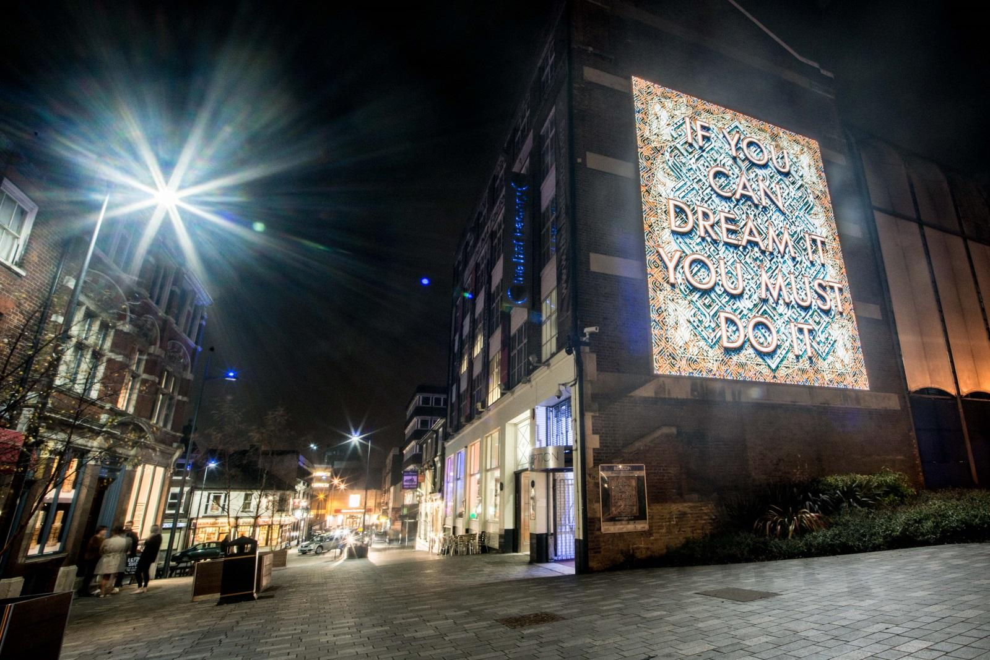

**Luton Matters: Public Artwork Commission – New South Asian artwork**

*Funded by The Steel Charitable Trust*

**Summary:**

We are pleased to invite artists and makers from Luton and beyond, who are working with an international reach, to submit an Expression of Interest for a public art commission within The Hat District, Luton’s Cultural Quarter.

One lead artist will be commissioned to produce a new permanent, Public art work to be developed and completed over 6 months celebrating South Asian culture in Luton using ‘global fashion’ as an artistic lens, exploring traditions of Luton and its local community. The lead artist will work with a second locally based artist and members of the community.

|  |  |
| --- | --- |
| **Timescale** | R&D (March) | Final Concepts ready for approval (April) | Prep work and community engagement (May – June) | Install (beginning July 2025) |
| **Budget** | Up to £15000 inclusive of Fee and install/fabrication costs. |
| **Closing Date** | Applications to be emailed to [sam.turton@culturetrust.com](mailto:sam.turton@culturetrust.com) by noon Monday 17th February 2025 |

|  |
| --- |
| 1. Introduction |

The Culture Trust Luton is an independent arts and cultural charity that produces and presents year round programmes across our venues; art centre, theatre spaces, museums, gardens and historic hat factories. We welcome local and regional visitors and we invite the wider community (national and international) to engage with Luton, an incredibly diverse and stimulating town. We actively commission artists and collaborate to produce new work, showcase inspiring high quality arts and culture, and celebrate Luton’s local community both within our venues and in the public realm.

This commission has been funded by the Steel Charitable Trust as a part of the Luton Matter Project which seeks to amplify creativity and community.

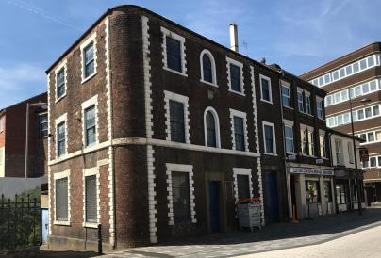 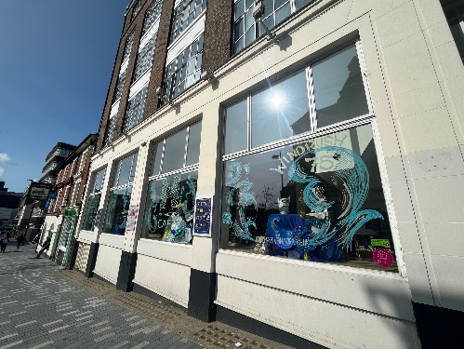 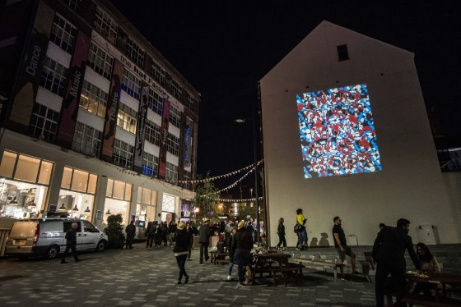

|  |
| --- |
| 2. The Brief |

This commission aims to celebrate South Asian Heritage in Luton using ‘global fashion’ as an artistic lens, exploring clothing, hat making and headwear traditions of Luton and its local community. Artists (or collectives) are invited to explore this rich heritage responding through the creation of a public artwork installation that reflects the people and place of Luton; with particular reference to Luton’s South Asian Communities. The artwork can be from any of the following nations (or more than one) - Afghanistan, Bangladesh, Bhutan, India, Iran, Maldives, Nepal, Pakistan, and Sri Lanka.

In line with the rich heritage of the Culture Trust and the multiple physical artworks in the Hat District, the trust would like to commission a new work to be placed on the exterior of the Hat Factory Arts Centre. The artwork will be a beacon for passers buy and specifically cover an area of the district that does not have a visible artwork in place. We envisage the commissioned artist to create multiple options, testing them using projection and working with the public of Luton and its South Asian communities to choose the final work, before install in time for South Asian Heritage Month 2025.

The artwork will inspire and capture local imaginations, providing opportunities for knowledge sharing and greater collaboration between creatives and the local community. We welcome artists to respond to the brief in whichever way they feel appropriate.

**Outputs:**

* A new semi-permanent artwork to be placed on the south west side of the Hat Factory Arts Centre in place by South Asian Heritage Month 2025. We are particularly interested in discussing works with artists working with Neon, light or unconventional visuals, but are not adverse to more traditional works.
* An engagement programme to support the development or delivery of the artwork.
* Documentation: budget, details of fabrication/materials, fabrication, maintenance and upkeep if required.

**Installation:**The artwork must be on display by South Asian Heritage month 2025. The schedule then may be agreed with The Culture Trust and the Luton Matters Producer. We recognise that the commissioned artist may not have the final artwork conceptualised by the submission deadline, but we would ask you to discuss the core concept at interview.

The artwork will be situated the Hat District in the footprint of Bute Street between The Hat Factory Arts Centre and the junction with Guildford Street and Cheapside. Please find a link to The Hat District website [here](https://hatdistrict.co.uk) for further information on the area and details on the existing artworks.

All artwork concepts will be reviewed in consultation with Culture Trust Luton, relevant partners and stakeholders before final sign off. We recommend that, where possible, the artist(s) undertake a site visit(s) to assess the areas and available locations, prior to submission.

The artwork/artworks will be attached to the external wall in the vicinity the Hat Factory Arts Centre, with engagement and consultation with the community on the final work securing a permanent legacy. It must be clear in the application which South Asian nation/nations you are representing in your proposal.

**Lead artist criteria required**

You will be a socially engaged artist/maker/designer with experience of developing and delivering successful public art commissions. You will have a track record in designing and installing work in the public realm and you will understand the issues relating to art in public areas, health and safety and public engagement/access.

It is desirable that the artist will have worked on an international platform, however this is not an essential requirement.

We are keen to ensure local people are given opportunities to engage in the development of this project. The lead artist will have support of the programme manager and the team at the culture trust in the consultation process surrounding 1) the options and 2) the final decision for the artwork.

We are open to a discussion about who fabricates and installs the work. If you are an artist with experience of this then please identify this as part of your initial application. The Trust would be willing to commission an artist for the design/concepts and then be responsible for install and fabrication.

We would like to run an education participation element of the project alongside the process. This will be discussed more with the artists if successful in receiving and offer for interview, but there may be a minimal commitment needed to creating publicity materials for this.

If you have a track record that demonstrates this experience, please apply.

**Terms and conditions:**

Full terms will be included in the contract. Key terms to highlight can be found below:

* The Culture Trust, Luton will assume ownership of the artwork and image rights once completed.
* The Culture Trust Luton will assume responsibility for the maintenance of the artworks once it takes on ownership.
* The artist will provide full details in relation to the fabrication and materials used, along with maintenance/upkeep information.
* The Artist will be credited where appropriate on or near the artwork in an appropriate form and on all images/materials containing reference to the artwork.

|  |
| --- |
| 3. Timescales |

|  |  |
| --- | --- |
| **Date** | **Event** |
| Jan/Feb 2025 | Approach potential artists to respond to brief |
| Mid/late February 2025 | Shortlist, Interviews & appointment to be made. |
| March 2025 | Announcement of Artist(s) and commencement of RnD. |
| Late April 2025 | Final concepts of first two installations and dates agreed. |
| July 2025 | First Public Artwork Installation (2 weeks at the beginning of July) |

|  |
| --- |
| 4. Applications & Selection Process |

To make an expression of interest for this opportunity please submit (email) the following:  
  
Completed proforma application (appendix 1)  
Up to 4 examples of your work with information (max. 2 sides of A4)  
Current Curriculum Vitae

All EOIs shall be assessed against the following information which you will need to supply in one document (PDF).

|  |  |  |
| --- | --- | --- |
| **Assessment area** | **The information you should include in your tender** | **% of assessment** |
| **40%**  **COST:** | **A fixed fully inclusive fee for the work.**  Include a full break-down of costs - this should include day rates for labour and other costs and relate to the outputs in section 2. | 40% |
| **60%**  **EXPERIENCE, SKILLS & ABILITY** | **A methodology** outlining how you would deliver the areas itemised in the brief requirements (relate to the outputs in Section 2). | 30% |
| **Letter of application** Outlining your relevant experience and track record in developing and successfully delivering/completing work similar to this brief.  · CVs for the artist(s) undertaking the work.  · 3 previous examples of related work.  · Details of your status as a business / self-employed artist. | 30% |
| **Two references** from a client who has commissioned you for work similar to this brief in the last five years. |
| **Availability** to meet timescale, outlining the start and finish date |

**APPENDIX 1**

**Luton Matters: Public Artwork Commission**

Name:

Address:

Email: Phone:

Applicants are advised to refer to the commission brief outputs outlined in section 2 to complete the next section.

1. **Art Form –** please describe initial ideas you propose for the art work (up to 500 words)

*Insert here*

1. **Approach to the commission -** A written statement of your ambitions for the commission and how you would approach it.  
   (up to 500 words)

*Insert here*

1. **Approach to engagement –** please outline an example of an activity you have delivered or would like to deliver, which you feel would successfully engage young people (16+) or diverse groups (up to 500 words)

*Insert here*

1. **Any other information that you feel we should be aware of that you feel would support your proposal**

(Up to 250 words)

*Insert here*

**Sign: Date:**

1. **Referees –** please provide contact details (email and telephone) for 2 referees, stating what relationship exists between yourself and the referee

*Insert here*

1. **Insurance –** please confirm you have or are willing to put in place public liability insurance to the value of £2,000,000.
2. **Availability** – please confirm your availability to start the commission within the relevant timeline given (see section 3 - timescale)
3. **Access** - Do you consider yourself to have a disability? Is there anything we can do to assist you to ensure you are able to fully participate in this opportunity?

**Please send this completed form, 4 examples of your work (max 2 sides of A4) and your CV to** [**sam.turton@culturetrust.com**](mailto:sam.turton@culturetrust.com) **by noon on 17TH March 2025.**